Grid Relay Fault

Author:Wesley
Reviewer:Eason

FAQ\Hybrid INV
Issue introduction
The error Grid Relay Fault on the inverter screen.
Confirmation of basic information
[Photo] SN numbers of inverters.
Guidance for installer
For the string inverter and single-phase hybrid inverter, simply upgrade the firmware to the latest version and restart the inverter. For the three-phase hybrid inverter, please follow the steps below for troubleshooting.
Step 1: Disable the three-phase unbalance function and restart the inverter.
Settings path: Setting→Advanced Setting→Phase Unbalanced
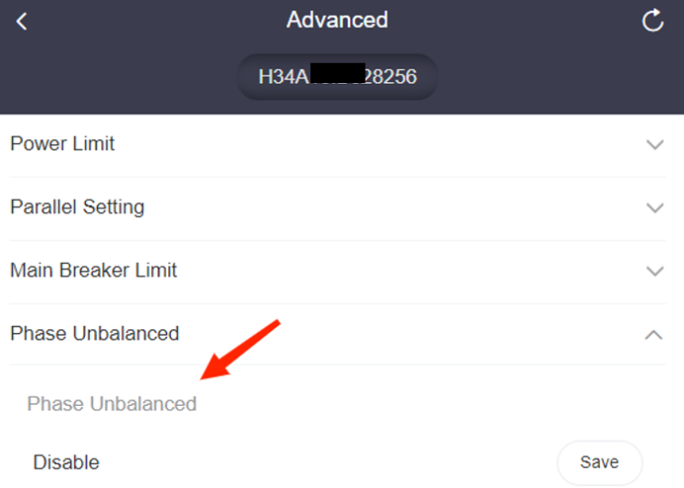
If the error disappears after disabling the function, check whether the neutral line is conductive with the grid.
Step 2: Check whether the neutral line is correctly connected. Set the multimeter to resistance mode and measure the resistance of the neutral line from the circuit breaker to the inverter grid port.
- If the measured result is close to 0, it indicates that the neutral line between the inverter and the grid is conductive.
- If the measured value exceeds the range, carefully check whether the neutral line is properly connected.
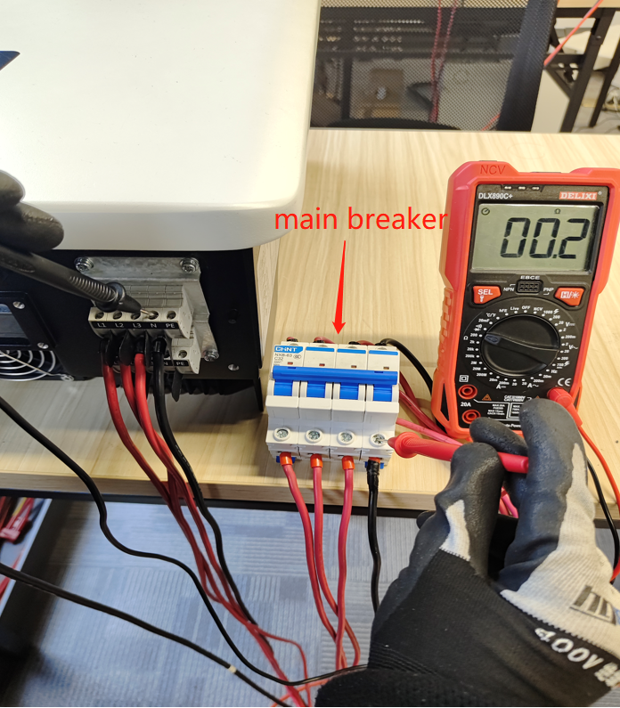
Step 3: If the MateBox is used, check whether the neutral line is connected correctly.
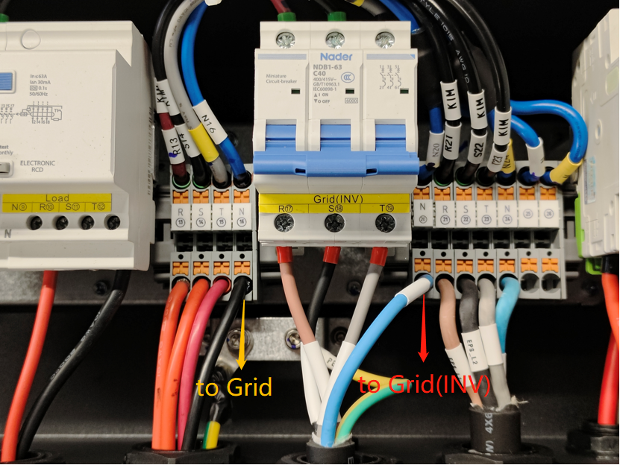 | Matebox basic
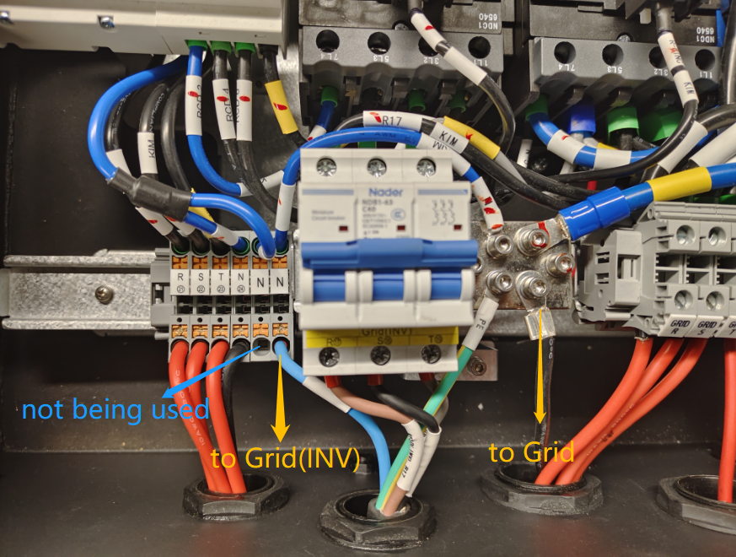 | Matebox  advanced
Information check list
If you have completed the above <Guidance for installer>, and the problem is still not solved, please collect the following troubleshooting information and send them to the R&D.
1. [Photo]SN numbers of the inverter.
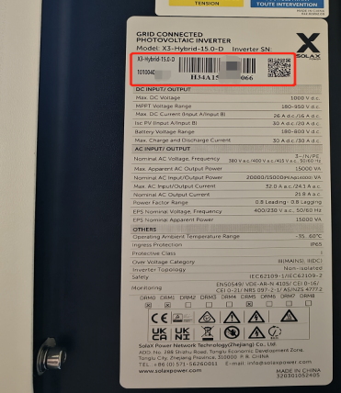
2.[Photo] The measurement result of whether the neutral line is conductive.
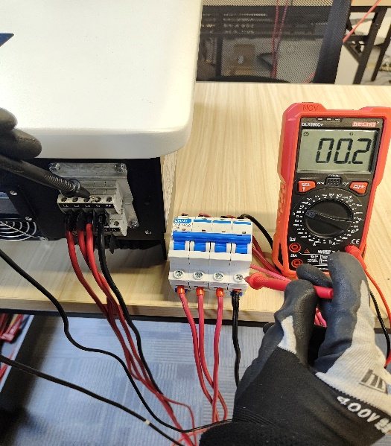
3.[Photo] The connection status of the neutral line(If the MateBox is used).
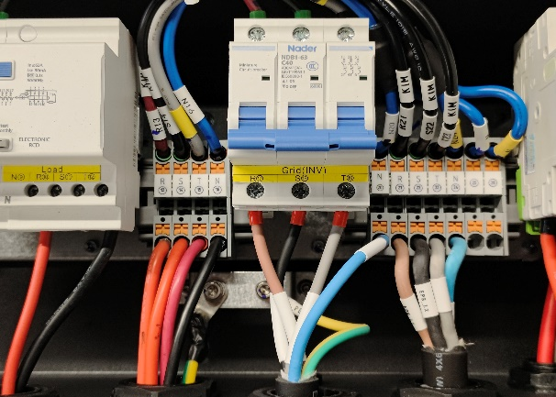 | 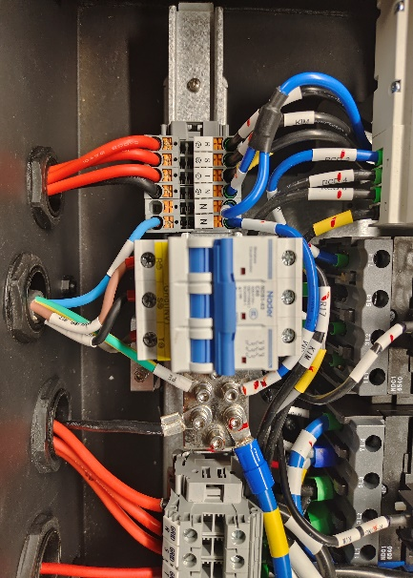
Matebox basic | Matebox advanced

